2013 ACE Critique and Awards Program
NMSU Media Productions — Jeanne Gleason

Math Snacks Website  Class 40:  Website | 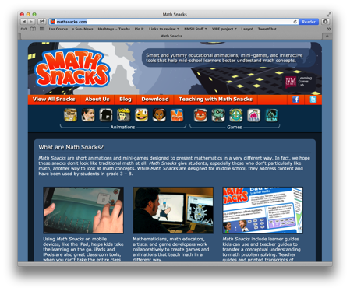
Math Snacks is available at mathsnacks.com
Overview:
Math Snacks includes animations, games and learning tools for middle school learners, addressing gaps in conceptual understanding of math concepts. Critical to the design of the website was the need to appeal both to mid-school learners and to their parents or teachers. It was also important to provide easy access to the Snacks themselves and to give teachers access to the tools designed to support instruction with the Snacks.
Purpose (goals, objectives, need):
NMSU’s Math Snacks initiative was funded by the National Science Foundation to develop innovative tools for teaching content addressed in the National Common Core mathematics standards. Math Snacks give students, especially those who don't particularly like math, another way to look at math concepts.
The purpose of the Math Snacks website is to provide easy access to the animations, games and supplemental tools. It must appeal to both youth and adults, engaging users to play and use all the snacks while inviting teachers to explore all the related content. This is a significant challenge: though there are only eleven snacks (six animations and five games), each Snack has a companion Teaching with Math Snacks video, a printable teacher’s guide, a learner’s guide and an illustrated transcript. Additionally, each animation can be viewed online (either on YouTube or from a different server for teachers working from behind firewalls), downloaded to view when offline, or viewed in a mobile device (iPhone, iPod, and iPad). All of the games are playable online, and some are also available for iOS.

Audience:
While Math Snacks is designed for middle school, it is used across New Mexico in grades 3–8. Middle school teachers say that Math Snacks is particularly helpful when students are slow to master more complex mathematics understanding because they failed to grasp key math concepts in grade school.
Marketing/promotion:
Currently in research phase, almost all Math Snacks are completed or in beta, and use of the tools in randomized control trials has begun. At this time, the website is being used by teachers and children engaged in research trials and by those who have been exposed to the product through presentations, articles in journals, during summer teacher training programs, and through online curriculum portals like Edmodo.com. In anticipation of widespread release of the tools in 2014, NMSU is developing a marketing and promotion plan through NMSU’s Math Snacks outreach initiative, supported by a full-time NMSU staff member. The availability of many of these Math Snacks on the Internet, iPhone and iPad makes it possible for students to enjoy Math Snacks games and animations during non-school time as well as in class. The sustainability and commercialization of the products is also being considered, building on current Math Snacks distribution partnerships with BrainPop, the National Council of Teachers of Mathematics (NCTM), and a successfully funded NSF I-Corp proposal to investigate commercialization.
Role of each entrant for the project:
All work, including animation, programming and instructional design, was produced in NMSU’s Media Productions studios. The specific team for each Snack is listed in credits. The overall team includes animators, artists, programmers, designers, content specialists, writers and editors. All have contributed in some way to the website development.
Extent to which project met goals and objectives:
Each game at the Math Snacks website is pilot tested throughout development. The results of research on tools have not yet been analyzed, but anecdotal reports from teachers and the pilot testing trials reveal that Math Snacks is both highly effective at teaching key concepts and also so much fun that kids forget they are learning math. Usability testing of the website with teachers indicates easy accessibility and “findability” of the key teaching materials.
How diversity was incorporated into your entry:
New Mexico has a Hispanic-majority public school student body populations and has long been considered a bellwether for future student body characteristics in the United States. Without competency in mathematics, students – particularly those in low-income areas, English language learners and students with special needs – are limited in their course and career options in STEM fields. Math Snacks has a proven track record of creating innovative products for all learners, with a design approach that involves underrepresented students throughout the design, development and testing phases of the products. Products have been tested extensively with diverse students and been reviewed by independent quality assurance panels annually, with specific attention paid to accessibility by diverse audiences and cultural sensitivity. Funders, such as the National Science Foundation, have found that interactive modules that test well with New Mexican students are often highly effective in increasing readiness to grasp STEM-related concepts within a national student population.

